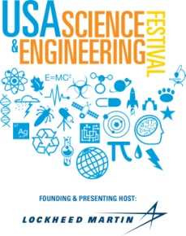
USA Science & Engineering Festival: Exhibitor/Presenter PR Tips
The USA Science & Engineering Festival has a multi-layered communications strategy designed to drive attendance at the Festival as well as increase exposure for the need for more young people to choose STEM careers. Part of this effort includes media relations outreach, which focuses primarily on generating press in the greater DC region in advance of the event. To do so, we:
- seek calendar listings—in print and online
- promote our Nifty Fifty program that sends scientists into local schools prior to the Festival since these individually appeal to hyperlocal community press.
- conduct many radio and TV interviews as well as drive-time radio mentions with DJs
- pitch many different angles and aspects of the event to targeted press to generate features
- promote the Festival’s April 6th Sneak Peek Friday as a press preview day
- manage press on-site to maximize exposure for the Festival and cause
In all, the event draws a significant amount of press from international, national, local, and trade outlets.
Opportunities
In Advance
As a Festival participant, we encourage you to help get the work out about your participation. Under the media kit on the website, we have press release templates to help you shape your messaging. Since we have local DC press covered, your best opportunities would be to pitch:
- Hometown press (outside DC)
- Vertical Markets
- National Press (including Festival sponsors listed on the website)
- Trades
Don’t forget to announce efforts using social media on Facebook, Instagram and Twitter. Use the hashtag #SciFest and the handle is @USAScienceFest.
On-Site
Many press show up to cover the event on-site—especially on April 6th for Sneak Peek Friday and Saturday, April 7th. With 3,000 exhibitors and 350,000 attendees, it’s not a great forum for in-depth interviews. Most reporters are interested in covering the event and crowd. However, make sure you have your on-site team prepared with talking points in case press does stop by your booth. You may also want to take pictures of your presence and send to your targeted trades and hometown press following the event.

Note: Sorry, but we are unable to release a press list in advance of the event as the list is very fluid. In addition, we are not staffed to accommodate the volume of requests.

